**September 17, 2015**

Acrylic/Plexiglas Experiment

1. Use an “acrylic cutter” or “sheet cutter” or “scoring knife” to score the acrylic and then snap it off. Better to score on both sides for an easy snap  
   **IMPORTANT: scoring + snapping is only effective with sheets up to ¼ inch (5-6mm) thickness. After that the sheet is too thick to bend n snap.  
   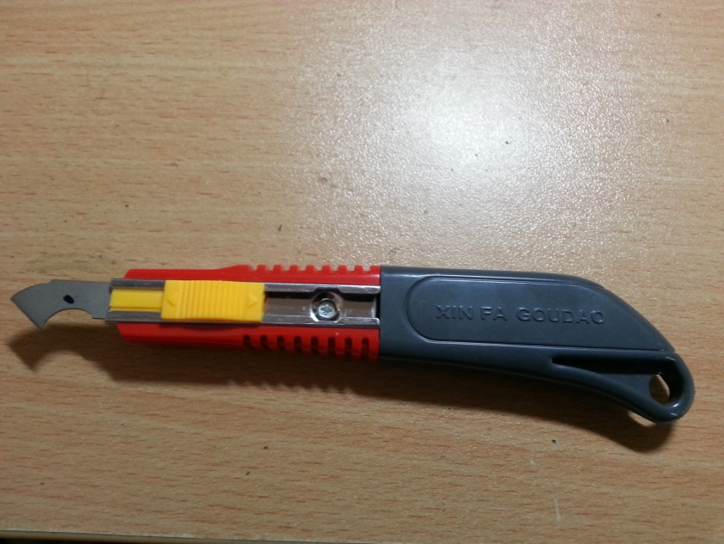**  
   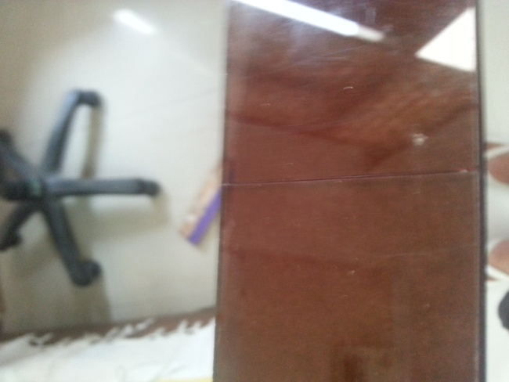 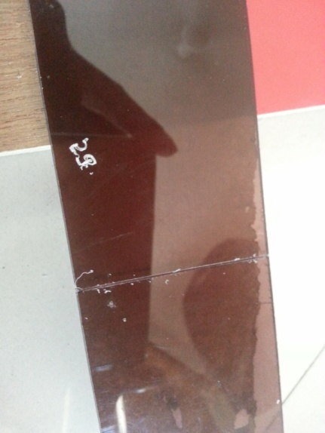  
   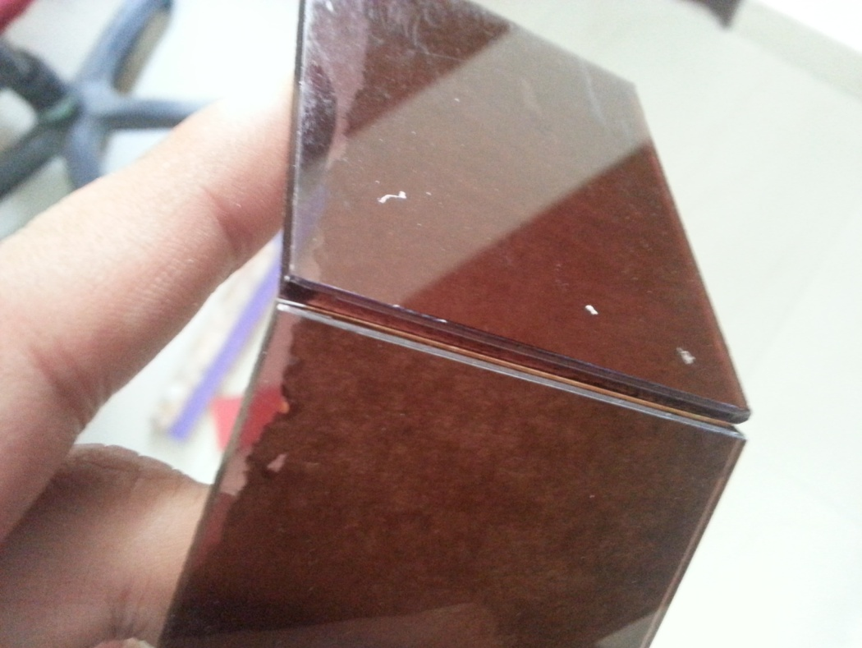
2. While drilling hole in acrylic don’t use fast rotary speed. Use a slow one. Using the fast one may shatter the sheet  
     
   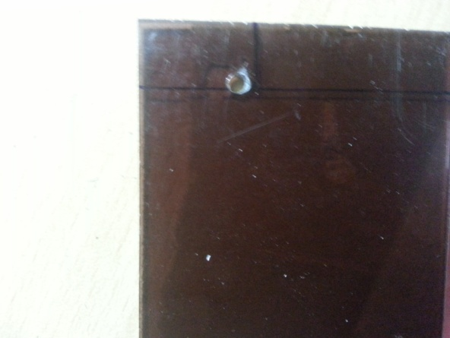
3. Acrylic sheet can also be cut with a fine blade hand saw.
4. To make corner cuts or to make non circular holes in acrylic, first make drill holes around the shape of the hole and then use a combination of handsaw and scoring to cut out of hole.  
   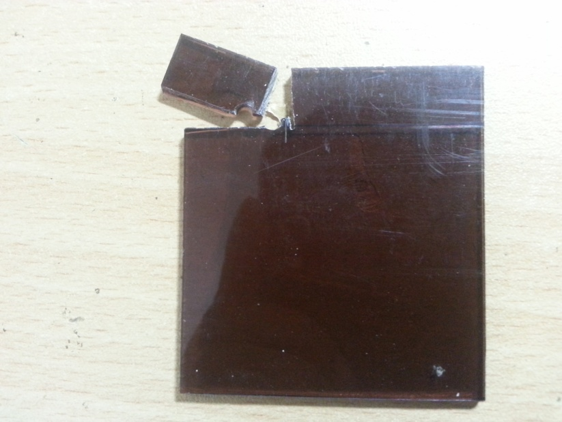
5. While scoring acrylic, make sure not to strike the scoring knife on a hard surface as that would break its edge.
6. Also while scoring or snapping the sheet, make sure to secure the acrylic to a surface using “**C clamps**” for better grip  
   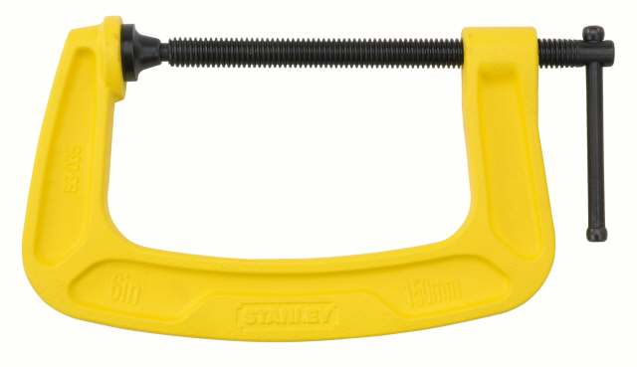
7. **IMPORTANT : make sure not to use bond glue / don’t bond acrylic pieces over traces on a PCB. The bond glue dissolves/disintegrates the pcb traces.**
8. **To stick acrylic**
   1. Make sure but the surfaces are FLAT. File edges if need be
   2. Dispense bond glue through a normal 2 ml needle with default 0.5mm tip. Note that you just need to dispense little bit of glue and it would flow between the surfaces through capillary action**.. IN BOND GLUE, EXCESSIVE GLUE DOES NOT MEAN A BETTER JOIN. YOU NEED THE RIGHT AMOUNT**